## Game tool design – RottenMapEditor

1. Introduction of RottenMapEditor ………………………………………………………… p2
2. General look about RottenMapEditor ………………………………………………….. p2
3. Layer ……………………………………………………………………………………………………. p2
4. Texture management …………………………………………………………………………… p3
   1. Adding textures ………………………………………………………………………….. p3
   2. Copy & Past ..……………………………………………………………………………… p3
   3. Multiple selections ..…………………………………………………………………… p4
   4. Change texture’s property.…………………………………………………………. p4
   5. Texture’s transformation ..…………………………………………………………. p4
   6. Delete ………………………………………………………………………………………… p5
5. Camera ………………………………………………………………………………………………… p5
6. Zoom ……………………………………………………………………………………………………. p5
7. The drawing order ……………………………………………………………………………….. p5
8. Undo & Redo ……………………………………………………………………………………….. p6
9. Save …………………………………………………………………………………………………….. p6
10. Primitives …………………………………………………………………………………………….. p7
11. **Introduction of RottenMapEditor**

RottenMapEditor is a general purpose, no tile-based Level Editor for 2d games of any genre that allows arbitrary placement of textures and other items in 2D space, user can directly backdrop images that they can translate, tint, rotate, scale, etc, in different parallax layers and camera zooming.

User can have several tilesets and can save/load the maps using XML files.

Custom Properties can be added to the items in order to represent game specific data between items.

RottenMapEditor is free software and is written in C# and XNA Game Studio 4.0. User need the XNA Framework and Microsoft .Net Framework to run it.

**2.0 General look about RottenMapEditor**

The structure of RottenMapEditor is, following each level consist several layers, following each layers consist several items, user can have as many layers as they want, and can have as many items as they want.

1. **Layer**

A layer is an overlay that includes a collection of texture items.

The first thing to do to edit a new map, is to create a layer, after create a new layer, the ‘items list panel’ will show up the new added layer to the list with a default name, like ‘Layer_0’, under the root node ‘RottenMap’.

When we have a layer, user can start to add textures, loaded textures are listed in the panel at right side of map editor, for loading new images in the editor, user can simply click to the ‘Load texture’ button at bottom of texture panel to load any images they want.

1. **Texture management**

**4.1 Adding textures**

To add textures in the map, RottenMapEditor give 2 solutions:

* User can drag the texture listed in the texture panel and drop in the current layer.
* Right click to the texture, a copy of the selected texture will follow the move of the mouse, and user can just put the texture by clicking again the right button of mouse.

Each new added image will be given a default node name by the map editor, like ‘texture_0’, ‘texture_01’, etc. And those image nodes will appears under the current layer’s node name in the ‘items list panel’.

For example, a map with 1 layer and 3 textures are showed like bottom in the RottenMapEditor:

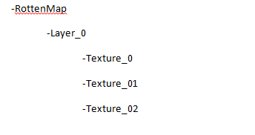

Of course, the item’s node name can be changed.

**4.2 Copy & Paste**

To copy an item, just select any texture, then right click at mouse button, select the copy in the pop upped submenu or holding the ‘ctrl’ key, click at ‘c’ key.

The paste is in similar way, select the paste option in the submenu or holding the ‘ctrl’ and click at ‘p’ key.

**4.3 Multiple selections**

In RottenMapEditor, user can select several textures at one time, to do so, it’s very simple, point the cursor to any blank space in the map (not inside of any textures), click and holding the left mouse button, a selection box appears, move the cursor to scale the selection box, any textures swallow by the selection box of current layer are selected.

RottenMapEditor represent also another way to do the multiple selections, holding the ‘ctrl’ key and click to any textures.

To move the selected textures, just move one of them, others will follow the same move. User can do the scale and rotate all them as well.

**4.4 Texture transformation**

In RottenMapEditor, user can do 3 basic transformations to the selected textures: move, rotation and scale.

* Move

To move a texture is very easy, just left click at any texture in the map, map editor will highlight the selected texture, then holding the clicked left button of mouse and move the mouse, the image will follow the move of the mouse.

* Rotation

To rotate a texture, right click the selected texture, a submenu popup, select the rotate option and the cursor image will changed, and appear a line which connect the center of texture to the cursor, then rotate the mouse.

* Scale

Scale works in the similar way, right click the selected texture, select the scale option in the pop upped submenu, and then scale with the wheel of mouse.

**4.5 Change texture’s property**

In RottenMapEditor, there have a property panel, which shows the divers information about the selected item, in the case of multiple selections, the property panel’s field remain blank.

The property panel shows the basic information of the selected item, the size in pixel, the position, the item’s default name, etc.

User can also add their custom property to the selected item, to do so, click to the right mouse button and select the ‘add new property’ option of the pop upped menu.

**4.6 Delete**

To delete an item in map, first select an item, right click to the selected item, and choose the delete option in the appeared popup menu, or once selected an item, click to the ‘Del’ in the keyboard.

The delete action can apply to the multiple selected items.

**5.0 Camera**

Camera move around with keys ‘w’, ‘s’, ‘a’, ‘d’ , user can hold down left ‘Alt’ key to boost the move speed. The speed can be configured in option tab, in the menu bar.

**6.0 Zoom**

RottnMapEditor let user to zoom in and out of the map using the mouse wheel, the speed of the zoom is also configurable.

User can center the camera to any items in the map, just select the texture and click to the F1 key.

**7.0 The drawing order**

In RottenMapEditor, the newer textures are always drawing on top of orders, but user can change the order of drawing by changing the position of texture node in the ‘items list’ panel.

It’s the same logic for layer’s order.

**8.0 Undo & Redo**

User can undo or redo every action, so just holding the ‘ctrl’ key and click at ‘z’ key to do the undo, for the redo, holding the ‘ctrl’ key and click at ‘y’ key.

**9.0 Save level**

To save the edited map, click at the ‘Save’ in the menu bar of RottenMapEditor or holding the ‘ctrl’ key and click at ‘s’ key.

The saved map is in xml file format, for example, a map consist 2 layers that in the 1st layer we have 3 textures and there have 2 textures in the 2nd layer, the saved map will show like :

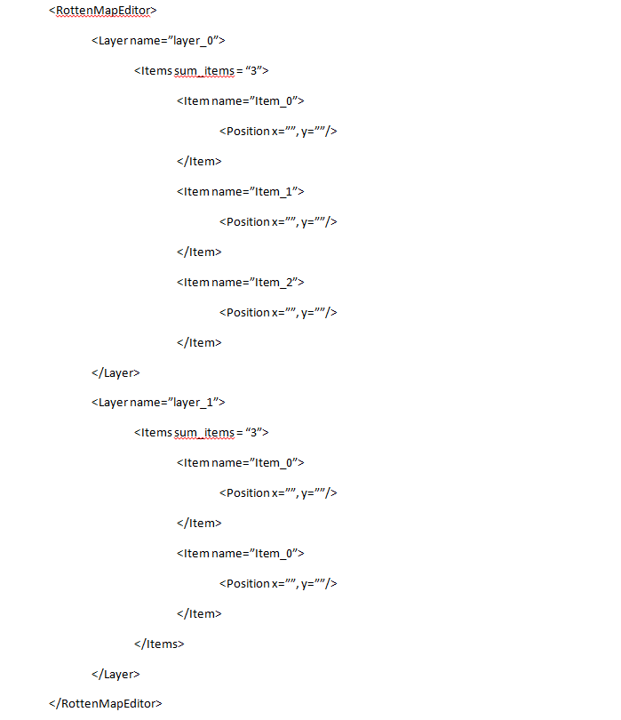

**10.0 Primitives**

RottenMapEditor have some primitive drawing, a rectangle, a circle and a path, the path primitive is a collection of connected points (the most recent placed point is connected automatically by his predecessor).

There could be found in the primitive panel, the purpose of those primitive is not strict, user can attach a rectangle primitive to a texture for the collision detection, or use it like a selectable area in the a point and click game, or use a path to define the moving logic of any enemy in an action game .